## 06.11.2019 - Wednesday

8:39 AM

So, I finished with the collaborative filtering algorithms that I wanted to add. Now it seems like it was a piece of cake.

Next thing that I want to do is to try using the Model-based techniques. First chapter of the book talks about the Decision Trees. Turns out that these trees are based on using the reduced matrices using the PCA or SVD technique. Well, penis :-D I avoided for so long to understand what SVD is and it turns out that it bit my ass now.

So, my next target was to understand what SVD is. I start with a couple of articles, the coolest one being <https://towardsdatascience.com/singular-value-decomposition-example-in-python-dab2507d85a0>

Well, that article says that SVD uses the PCA to find the best axes for projecting … Well, great, I have no clue how PCA works ☺ I switch to this article <https://towardsdatascience.com/https-medium-com-abdullatif-h-dimensionality-reduction-for-dummies-part-1-a8c9ec7b7e79> and it honestly just seems like there’s a full road ahead of me …

I also came back to videos of this guy <https://www.youtube.com/watch?v=LyGKycYT2v0>

At this point, I believe I’ll have to recall what the dot product is, what the eigenvectors are, etc. I do vaguely remember of all of that, but I honestly have no faintest idea how it works.

So, next tasks 🡪 recall the Dot product, try to understand the PCA and hopefully try to understand the SVD. Yeah, it can be done using the numpy library but I actually want to see what it is really …

And yeah, I’m a bit pissed because I have no idea if I’m just wasting my time now or not … Who knows …

Finally, to be honest, I believe that my Master thesis is already good enough as it is. But I just want to teach myself how the Model-based techniques work and, frankly, WTF SVD is …

First important thing that I learn is *“The main objective of dimensionality reduction is this:****find a low-dimensional representation of the data that retains as much information as possible.****”* ([source](https://towardsdatascience.com/https-medium-com-abdullatif-h-dimensionality-reduction-for-dummies-part-1-a8c9ec7b7e79))

*This is essentially****Dimensionality Reduction:****finding the best low dimensional representation of the data.* ([source](https://towardsdatascience.com/https-medium-com-abdullatif-h-dimensionality-reduction-for-dummies-part-1-a8c9ec7b7e79))

Seems like I’ll have to remind myself of axis rotation, etc. I do remember that 3 Blue 1 Brown guy was talking about it.

So, from what I understood so far, PCA is about finding the best axes where to project the data, then finding the axis that has highest variance and dropping the ones with lower variance. But, how to find those? That seems to be part of SVD or whatever? No idea yet …

9:00 AM

I was watching this <https://www.youtube.com/watch?v=LyGKycYT2v0&list=PLZHQObOWTQDPD3MizzM2xVFitgF8hE_ab&index=10&t=0s> but I don’t have time to finish it … hopefully tonight

6:00 PM

Ok so I’m pretty much tired and I’ll take just a quick glance over everything. So, to recap, this is what I want to understand:

1. What is PCA? What are the basic principles of it?
   1. I don’t have to be able to implement it myself but I should at least be familiar with its inner workings, what Eigenvectors are, etc
2. The god-damn dot product …. I guess I need to get more familiar with it
3. What is SVD and how it works? No need to know the inner details but I should at least be familiar with products of it

Once I’m familiar with those stuff, I’d like to be able to do following:

1. Make some sample implementations for PCA and SVD in Python
2. Go back to book and understand how are these techniques used in Recommender systems

So, let’s start with PCA …

Perfect quote that I’ve seen in Video: “The introduction of numbers as *coordinates* is an act of violence!” ([source](https://www.youtube.com/watch?v=fNk_zzaMoSs&list=PLZHQObOWTQDPD3MizzM2xVFitgF8hE_ab&index=1)).

So vectors are, from “mathematican’s point of view” ordered sequences of numbers that can be represented graphically (using a coordinate system). E.g. $\left[\begin{matrix}3 \\ 1\end{matrix}\right]$ is a vector that can be represented by moving by 3 to the left and 1 to the top.

Vector addition really represents what you’d get if you just moved straight there. For example: $\left[\begin{matrix}3 \\ 1\end{matrix}\right]$ + $\left[\begin{matrix}4 \\ 2\end{matrix}\right]$ = $\left[\begin{matrix}7 \\ 3\end{matrix}\right]$. This is the same as saying – first move 3 to the left, then 1 up. Then go 4 left and 2 up. We end up at 7 left and 3 up, which is the same destination we’d get to if we moved 7 left and 3 up.

Basis vectors are $\hat{i}$ and $\hat{j}$. They are vectors of length 1 and generally, any number in the vector (e.g. $\left[\begin{matrix}3 \\ -2\end{matrix}\right]$ means that $\hat{i}$ is three times and $\hat{j}$ is 1 time):

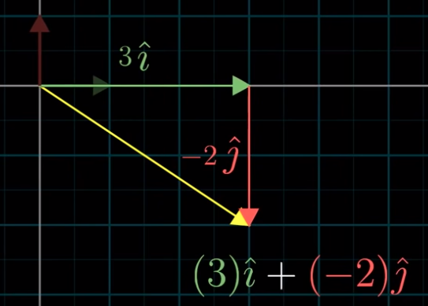

Technically, we can choose any pair of basis vectors. Depending on what we choose, most of the time we can really reach ANY other vector. And these vectors that we reach are actually called “Linear combinations”.

Also, The “span” of $\vec{v}$ and $\vec{w}$ is the set of all their linear combinations:

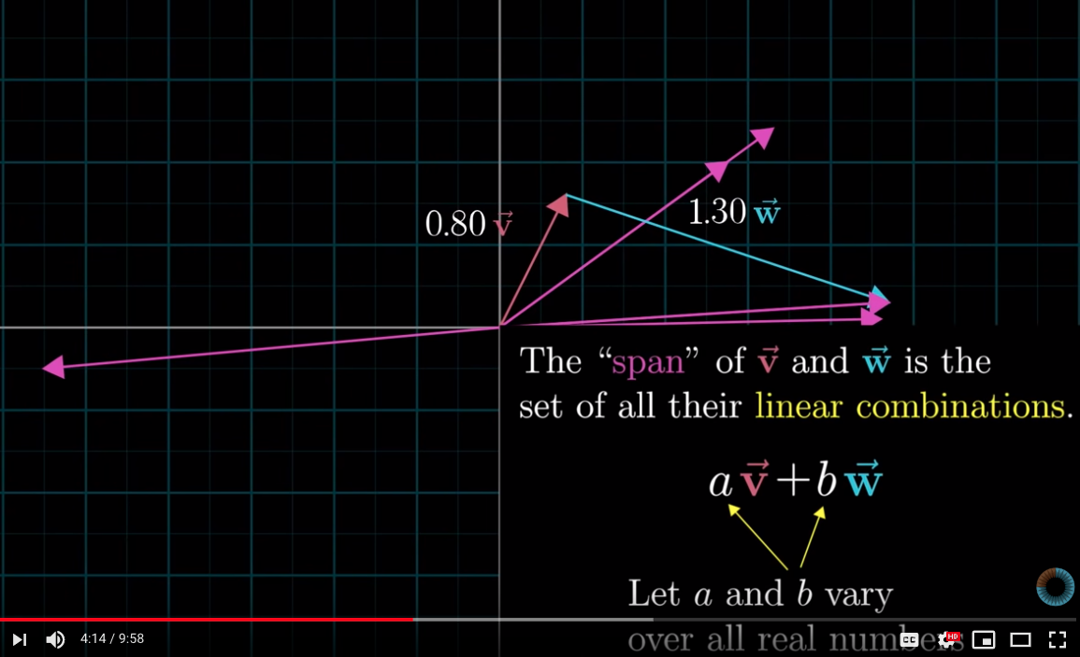

Generally, span of any two basis vectors is all vectors in that dimensional space. Exceptional scenario is when basis vectors are lined up:

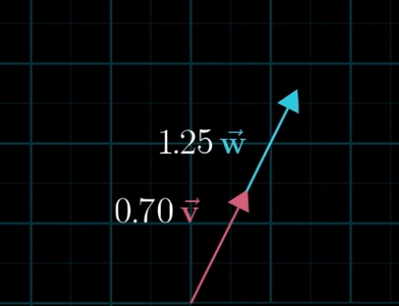

Then, the span is only one dimension, as it can only move up or down …

The terminology when we have vectors that are sitting on the same plane and where one of them is redundant is called [“Linearly dependent vectors”](https://youtu.be/k7RM-ot2NWY?list=PLZHQObOWTQDPD3MizzM2xVFitgF8hE_ab&t=511)

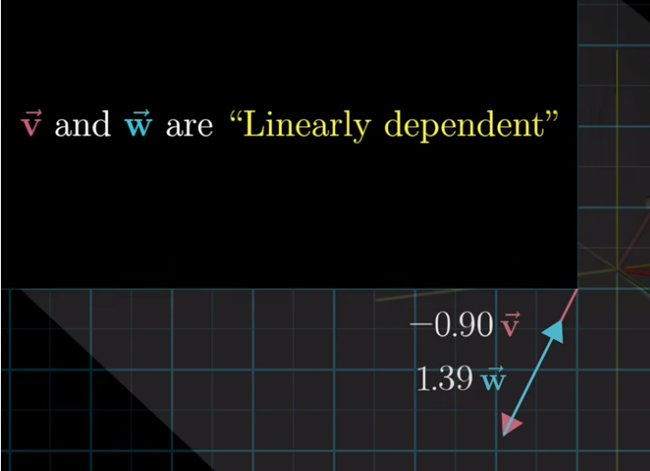

If, however, new vector DOES add a new dimension to the span, they are said to be [“linearly independent”](https://youtu.be/k7RM-ot2NWY?list=PLZHQObOWTQDPD3MizzM2xVFitgF8hE_ab&t=532).

**The basis of a vector space is a set of linearly independent vectors that span the full space.**

According to [Wikipedia](https://en.wikipedia.org/wiki/Basis_(linear_algebra)): “In mathematics, a set B of elements (vectors) in a vector space V is called a basis, if every element of V may be written in a unique way as a (finite) linear combination of elements of B. The coefficients of this linear combination are referred to as components or coordinates on B of the vector. The elements of a basis are called basis vectors.”.

Vector transformations describe how vectors move from starting to ending position.

[Linear transformations](https://youtu.be/kYB8IZa5AuE?list=PLZHQObOWTQDPD3MizzM2xVFitgF8hE_ab) are called linear if they satisfy the following properties:

1. Lines remain lines
2. Origin remains fixed

Funny enough, if we describe each transformation as “where the” $\hat{i}$ and $\hat{j}$ basis vectors land, then the matrix multiplications is really a transformation of a vector using the linear transformation. Specifically, it describes where the vector lands after applying the transformation.

Funny enough, seems like matrix multiplications is really just a transformation of space … LOL.

One way of capturing where vector lands after TWO linear transformations is:

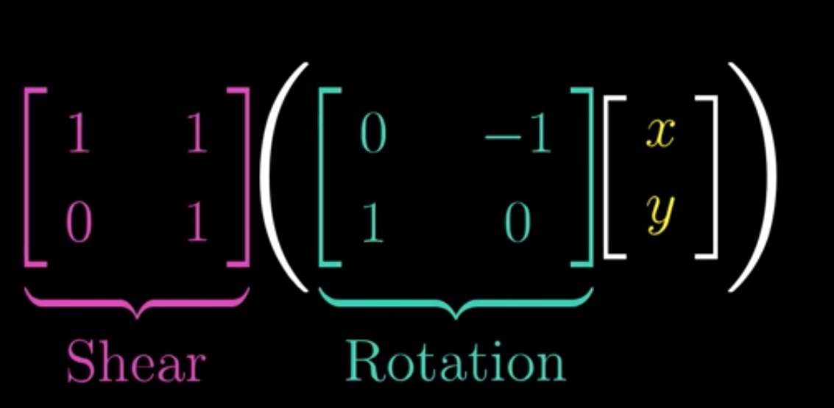

Which is interesting.

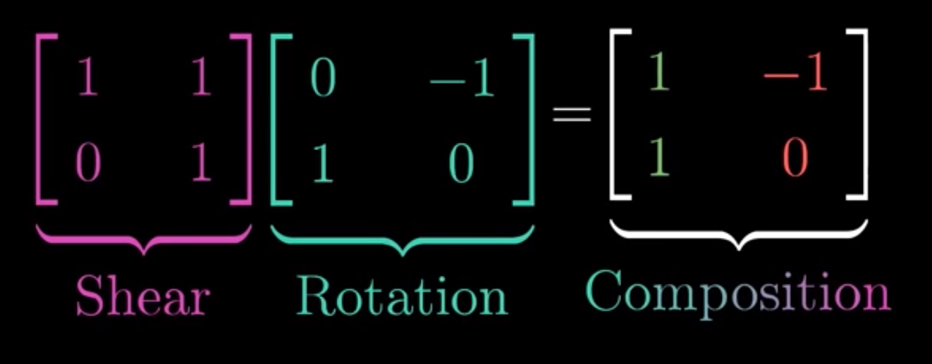

Basically, we can think of matrix multiplication as applying one transformation, then another to get to the end result.

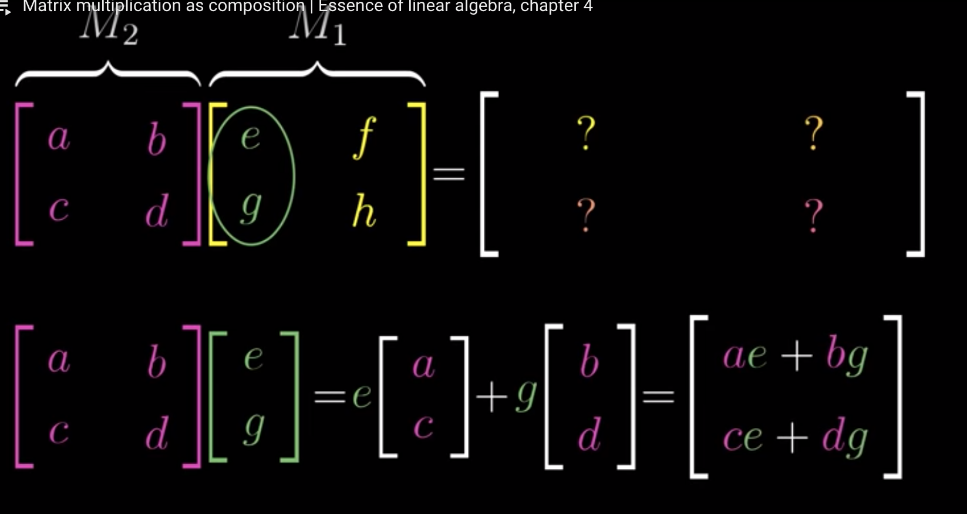

It’s really all about where the $\hat{i}$ and $\hat{j}$ go.

All in all, thinking about multiplication as a series of transformations is actually so cool that … hell, how do you even forget it, lol. Relevant video: <https://www.youtube.com/watch?v=XkY2DOUCWMU&list=PLZHQObOWTQDPD3MizzM2xVFitgF8hE_ab&index=4>

## 07.11.2019 – Thursday

08:00

Battle plan for today: watch two videos about Math from 3Blue 1Brown, then take one area that I didn’t finish in Master thesis and finish it (e.g. Implicit VS Explicit ratings stuff).

As a reminder – goal is to understand the PCA, SVD, eigenvectors, etc. so that I can implement at least one algorithm that uses them.

So, first video was about 3D transformations and basically describing that matrix multiplications is nothing more than vector transformations:

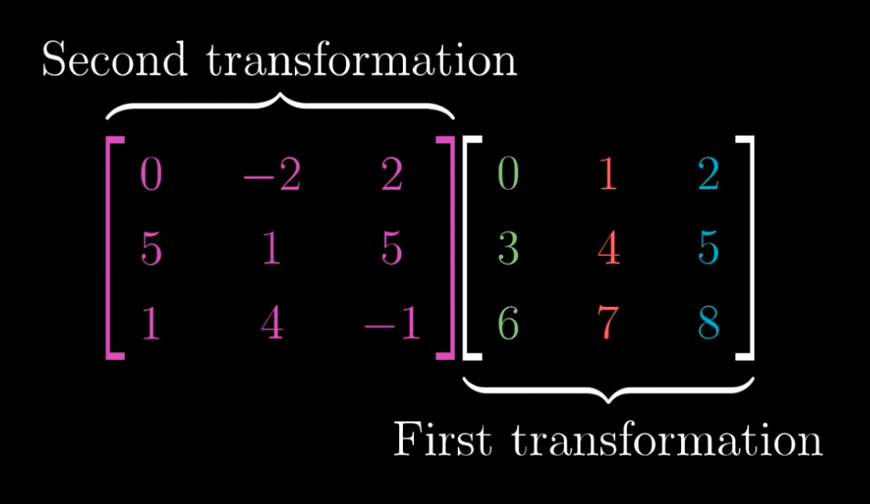

Next video is about determinant. That’s not bad to see …

[Next video](https://www.youtube.com/watch?v=Ip3X9LOh2dk&list=PLZHQObOWTQDPD3MizzM2xVFitgF8hE_ab&index=6) is about a determinant. Apparently, what a DETERMINANT is – it describes how much the space stretches or shrinks after applying the transformation:

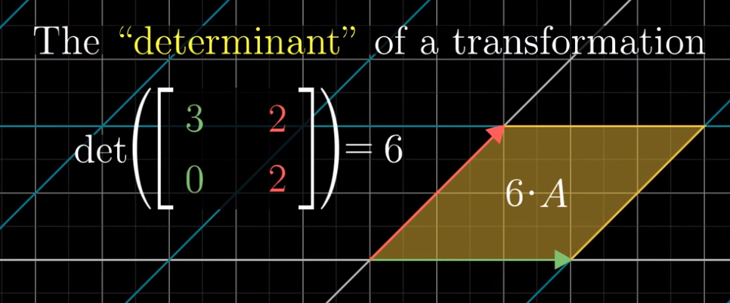

In above case it increases the space by factor of 6.

Interesting scenario is when it squishes the space onto a single line:

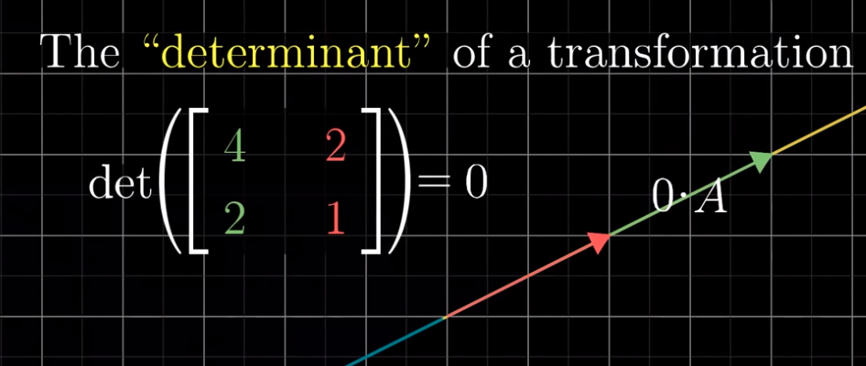

Then, it’s a zero.

[Another interesting scenario](https://youtu.be/Ip3X9LOh2dk?list=PLZHQObOWTQDPD3MizzM2xVFitgF8hE_ab&t=227) is – whenever the orientation of matrix changes (i.e. invertes) then the determinant is negative:

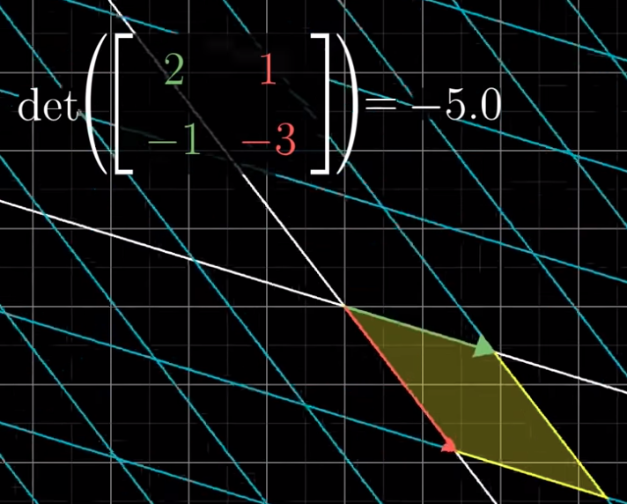

What is meant by intert is that, in the starting position $\hat{j}$ is to the LEFT of $\hat{i}$. If after transformation it ends up to the RIGHT, then we say that the orientation has inverted.

In terms of 3D, it tells you how much the VOLUME scales.

Formula:

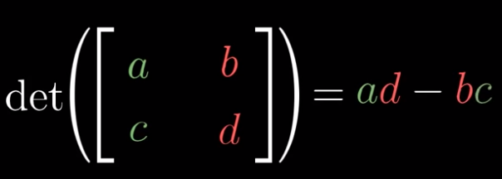

[Here’s intuition](https://youtu.be/Ip3X9LOh2dk?list=PLZHQObOWTQDPD3MizzM2xVFitgF8hE_ab&t=460).

Really cool stuff. I totally forgot about it.

[Next video](https://www.youtube.com/watch?v=uQhTuRlWMxw&list=PLZHQObOWTQDPD3MizzM2xVFitgF8hE_ab&index=7) is about Inverse matrices. That’ll stay for tonight. Let’s see what is left in Thesis now.

09:00

Watched two videos, as planned. Wrote about Explicit and Implicit ratings and Similarity coefficients.

Started reading about Recommender Systems in Software Engineering in <https://www.researchgate.net/profile/Gerald_Ninaus/publication/261263565_recommender_systems_future/links/00463533bd544bf3c3000000/recommender-systems-future.pdf>

To be continued tonight …

## 08.11.2019

08:00

Didn’t manage to do some studying in the evening. Continuing now. Plan is to watch 2 videos on math and then write about recommender systems in software engineering a bit.

Linear equations are equations where vectors are multiplied by scalars only. No sin(x), no multiplication of vectors. Only scaling of them:

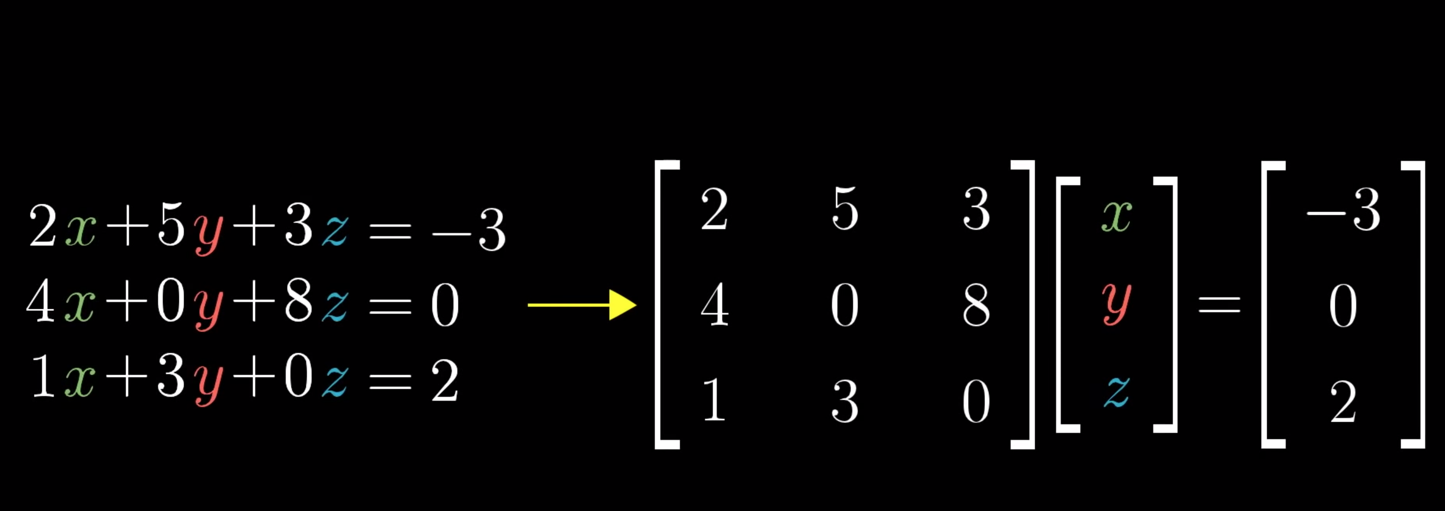

As can be seen, these equations can be [represented as matrices](https://youtu.be/uQhTuRlWMxw?list=PLZHQObOWTQDPD3MizzM2xVFitgF8hE_ab&t=140).

[Inverse of the transformation](https://youtu.be/uQhTuRlWMxw?list=PLZHQObOWTQDPD3MizzM2xVFitgF8hE_ab&t=291) represents the transformation that returns vectors back to original positions:

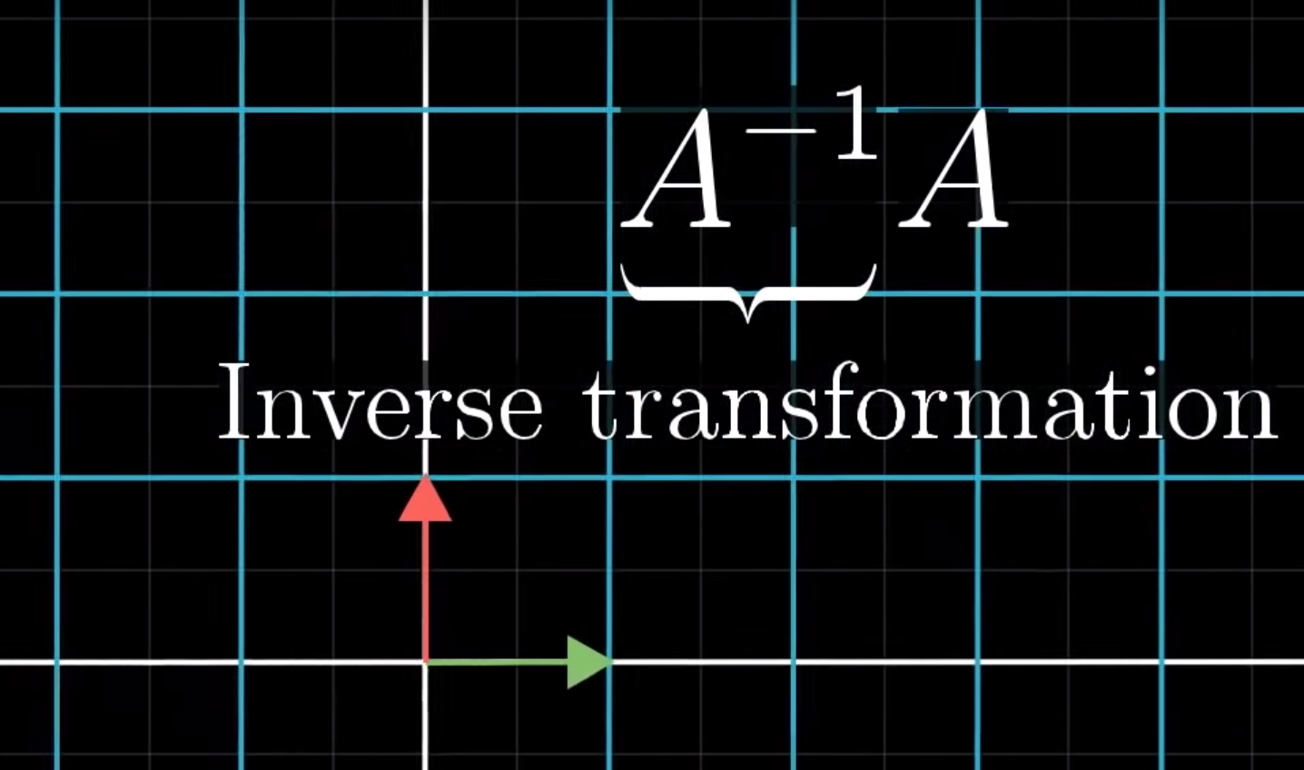

So if A was a transformation, then $A^{-1}$ would return A back to original.

The transformation that does NOTHING is called **IDENTITY TRANSFORMATION.** This on leaves $\hat{i}$ and $\hat{j}$ intact.

When the determinant det(A) = 0, then there is NO inverse of a matrix ($A^{-1}$). This is because when determinant is 0, the space is squished into a line, and [there is no inverse transformation that transforms a line back into a plane](https://youtu.be/uQhTuRlWMxw?list=PLZHQObOWTQDPD3MizzM2xVFitgF8hE_ab&t=416).

When transformations squishes the space into a LINE (1 dimension), then we say that it is a RANK 1. If all vectors land on a PLANE, we say that RANK is 2.

[Rank = number of dimenstions in the output](https://youtu.be/uQhTuRlWMxw?list=PLZHQObOWTQDPD3MizzM2xVFitgF8hE_ab&t=507).

Set of all possible outputs A $\vec{v}$ (A = transformation, $\vec{v}$ = vector) is called [“Column space” of A](https://youtu.be/uQhTuRlWMxw?list=PLZHQObOWTQDPD3MizzM2xVFitgF8hE_ab&t=543).

[Full rank](https://youtu.be/uQhTuRlWMxw?list=PLZHQObOWTQDPD3MizzM2xVFitgF8hE_ab&t=576) = when matrix ends up in the same number of dimensions as before.

[Null space / Kernel](https://youtu.be/uQhTuRlWMxw?list=PLZHQObOWTQDPD3MizzM2xVFitgF8hE_ab&t=640) == space of all vectors that land on ORIGIN (zero vector) of the axis.

Well, this video was pretty .. heavy. Lots of new stuff introduced and I’m kind of pretty sleepy. Let’s see how the next one does.

So, what he demonstrated in [this video](https://www.youtube.com/watch?v=v8VSDg_WQlA&list=PLZHQObOWTQDPD3MizzM2xVFitgF8hE_ab&index=8) is that you can have the matrices that have 3 dimensions but are defined in 2-d space:

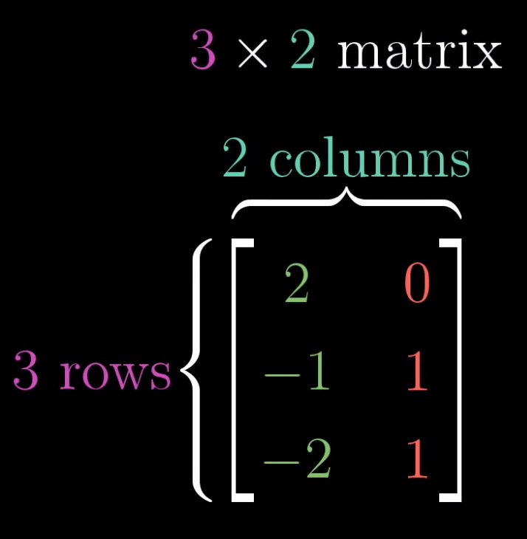

This was 3D ending up in 2D, this is 2D landing in 3D:

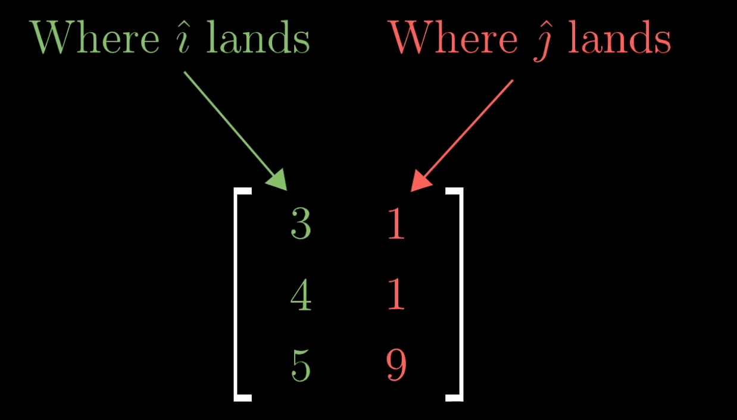

Rather interesting …

Next video is about dot product … Let’s see a bit of it, I say …

Fu, OK, the next video totally screwed me up with dot product and projections … So, is the dot product the same as matrix multiplication?

[Answer](https://math.stackexchange.com/a/2354058): Dot product is defined between two vectors. Matrix product is defined between two matrices. They are different operations between different objects.

Ok, I’m going back to a bit of reading about recommender systems.

17:00

Ok, back from work. I’m pretty nervous and tired but I’m hoping to do some figuring out about dot product, etc.

Ok important things that I learned:

1. Dot product seems to be pretty useful in Physics. It seems to have some real-life applications
2. **It seems to be good for seeing whether the two vectors are pointing in the same direction (then the dot product is POSITIVE), perpendicular (dot product is zero) or in opposite direction (dot product is negative)**

Generally speaking, the dot product seems to represent the projection of the first vector onto the second vector and then multiplying it with second one:

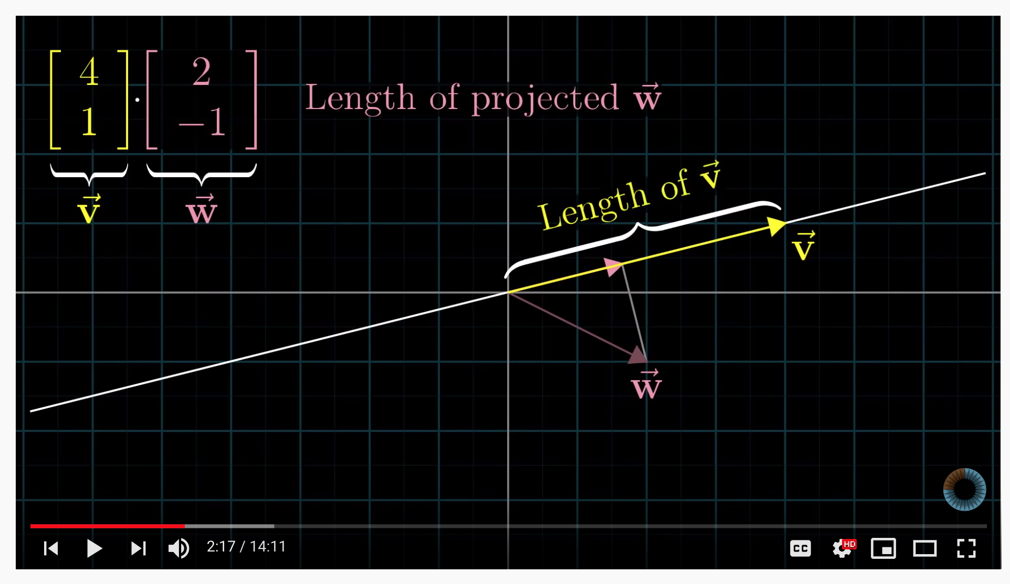

## 09.11.2019 – Saturday

11:40

Ok, decided to sleep a bit more tonight, especially since I was exhausted as crap yesterday.

What I managed to realize yesterday actually is something that has been bugging me ever since. So, there’s this formula:



What it actually means is that numerical dot product of a and b vectors is the same as geometrical one where we multiply magnitudes and cosine of the angle. Which is actually interesting because you can get cosine theta by dividing the dot product with product of magnitudes. Which is something I’ve seen being done as a fast way to calculate cosine of vectors but I had no idea what it was :-D

Anyway, I’ll do one more round of watching the Dot products since I have to understand the duality as well, and then we’ll see the rest.

Aha, so I finally realized what he was talking about. So his point is that, whenever you have a transformation that takes 2D to 1D (i.e. number line), there is a unit vector that represents that transformation! And coordinates of that unit $\hat{u}$ vector are exactly the (x, y) coordinates of $\hat{i}$ and $\hat{j}$!

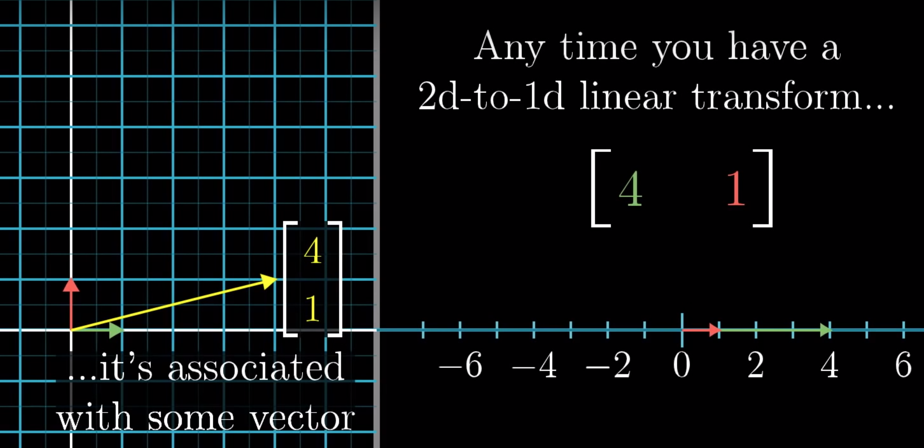

More about it [here](https://youtu.be/LyGKycYT2v0?t=727).

Apparently, this is what he calls **DUALITY**. No idea yet of WHY it’s called that, but let’s see.

All in all, as he says, the most important thing to remember is that DOT product tells you if two vectors are going in the same direction or not.

Now on to CROSS PRODUCT. So, the cross product represents the shape of parallelogram defined by two vectors:

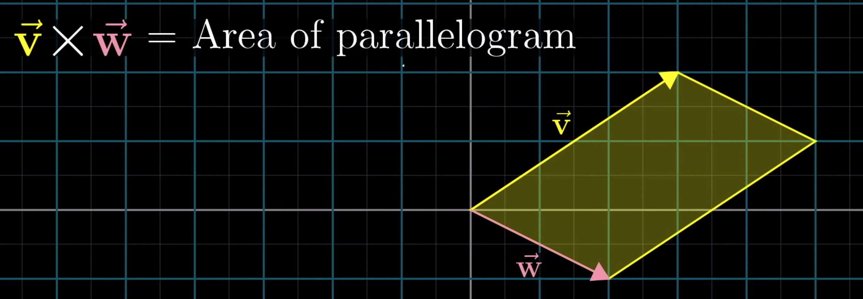

Funny enough, it turns out that this is exactly what determinant is – area of parallelogram defined by two vectors. It’s positive if the î lands to the right of $\hat{j}$, or negative if the perspective is reversed.

Important note: the more perpendicular the vectors are, the area is BIGGER. Kind of opposed to the dot product.

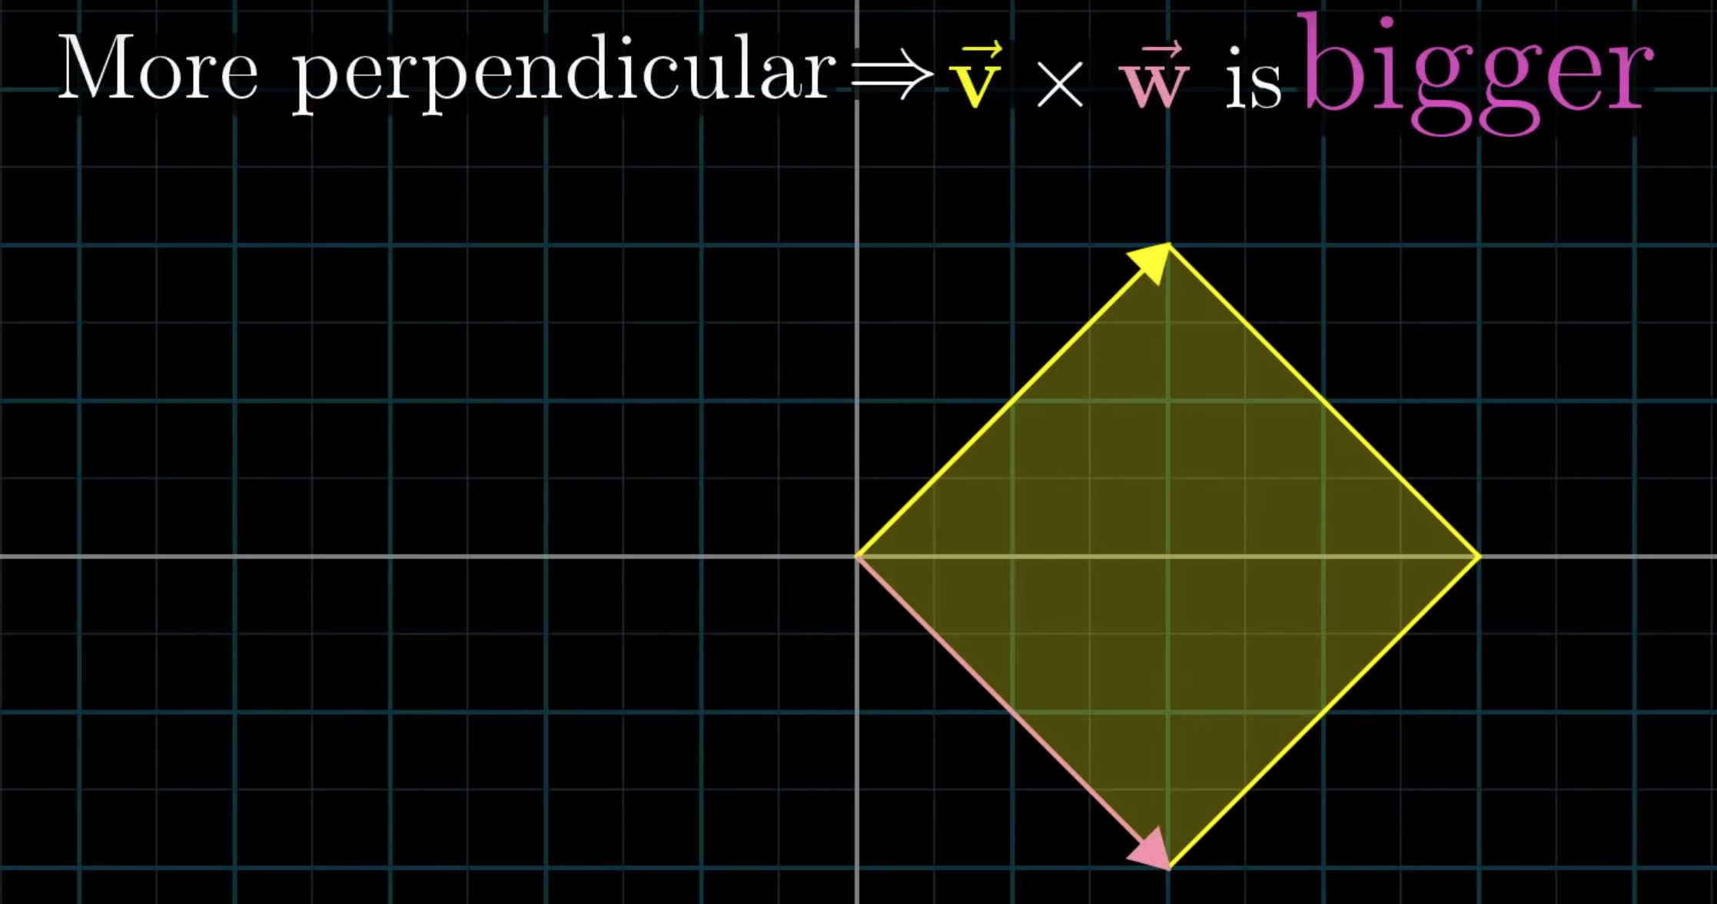

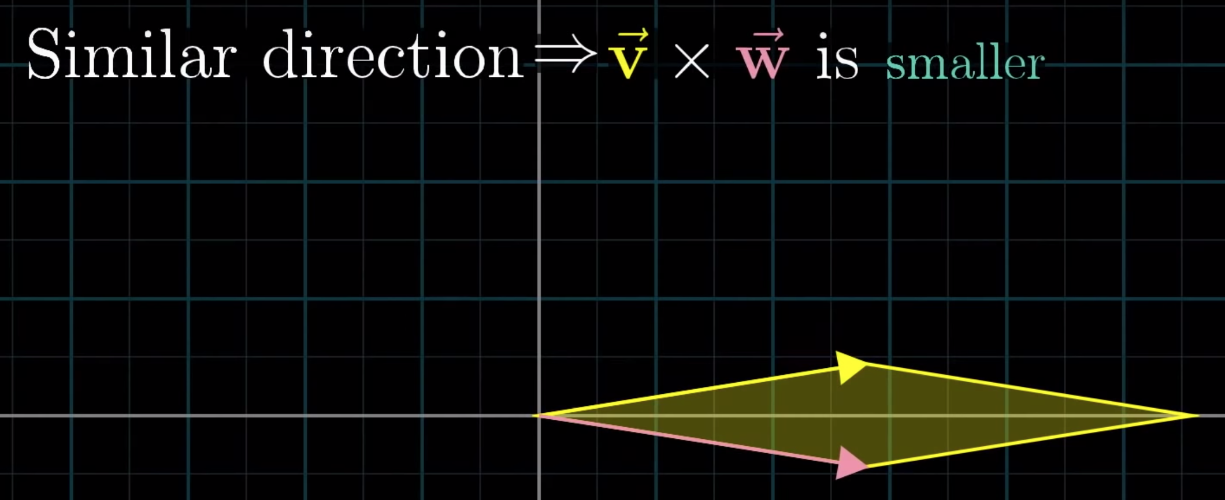

Ah it’s not a determinat. The cross product of two vectors is actually a vector whose length is the “determinant”, and it’s direction is perpendicular to the parallelogram defined by two vectors:

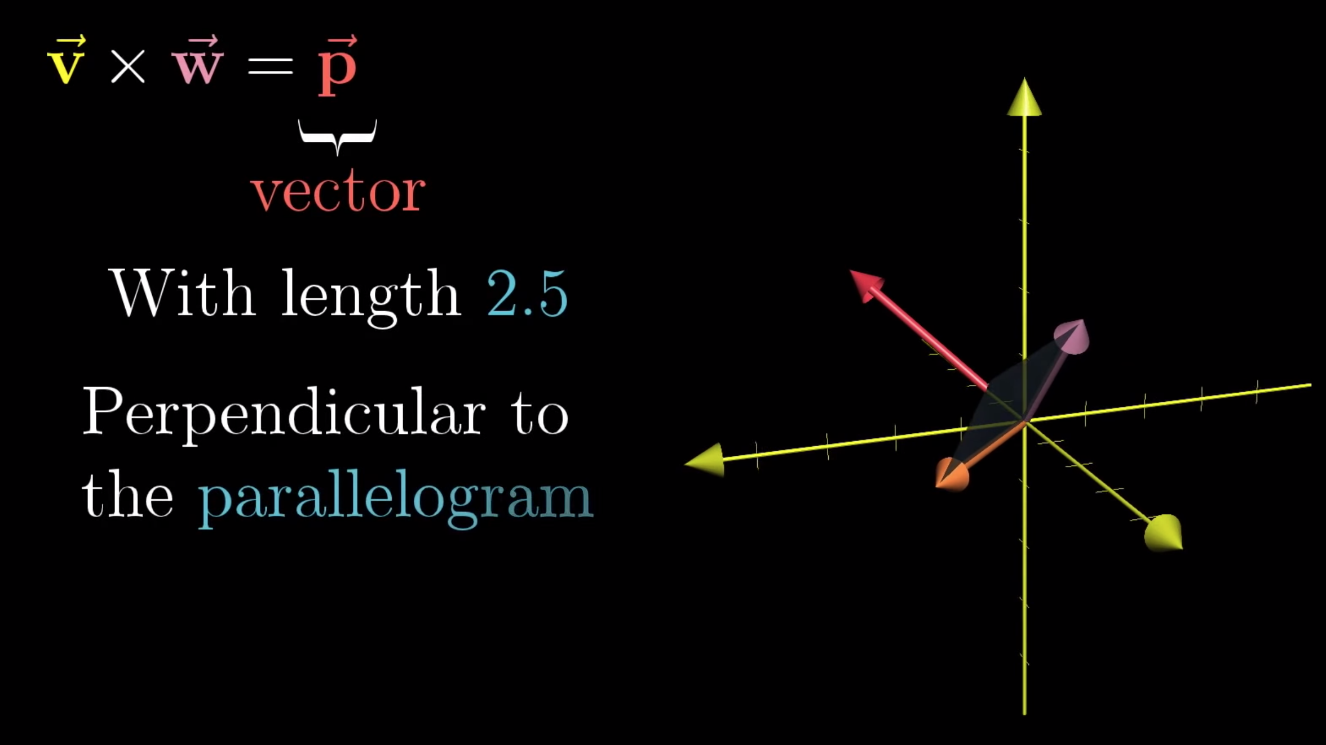

Fuu, this one was pretty heavy, especially geometrically. I’ll leave it to …. Pause and ponder, while I deal with writing of thesis a bit.

Next video is 🡪 [Cramer's rule, explained geometrically](https://www.youtube.com/watch?v=jBsC34PxzoM&list=PLZHQObOWTQDPD3MizzM2xVFitgF8hE_ab&index=12).

13:20

Ok, after a short break, time to continue. I’ll do a bit of writing now. I’d like to finish the “Recommender systems in Software Engineering” topic and eventually to write about knowledge-based systems.

14:02

Ok, I’m done writing about Recommender systems in SE. Short break and then going to write about Future of Recommender systems.

15:20

Finished writing about future of recommender systems and taking a break. I’m going to continue watching math videos.

So, Cramer’s rule is a way of solving systems of equations with multiple unknowns. Not sure if and how relevant will that be for what I need, but I guess it’s not bad to know it ?

Next one is – Change of basis and after that we finally arrive to what I was waiting for – Eigenvectors!



Any way to translate between vectors and sets of numbers is called “coordinate system”.

Ok so this will take time to digest … Basically, he was talking about transforming from our basis to other basis’, which seems to be important for Eigenvectors and eigenvalues …

Eigenvectors are vectors that remain on their line during the transformation. Eigenvalue is the amount by how much is eigenvector stretched or squished.

Eigenvetor is actually the AXIS of rotation.

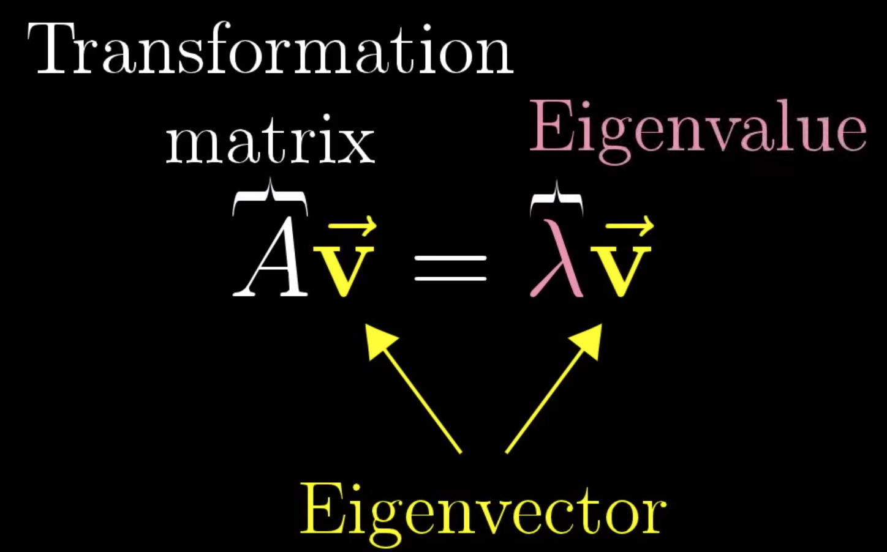

What this says is that A $\overset{⃑}{v}$ = $λ\overset{⃑}{v}$ or multiplying vector $\overset{⃑}{v}$ with matrix A is same as finding a lambda that scales $\overset{⃑}{v}$. $λ$ is the eigenvalue ;-)

Diagonal matrix is a matrix where all basis vectors are eigenvectors:

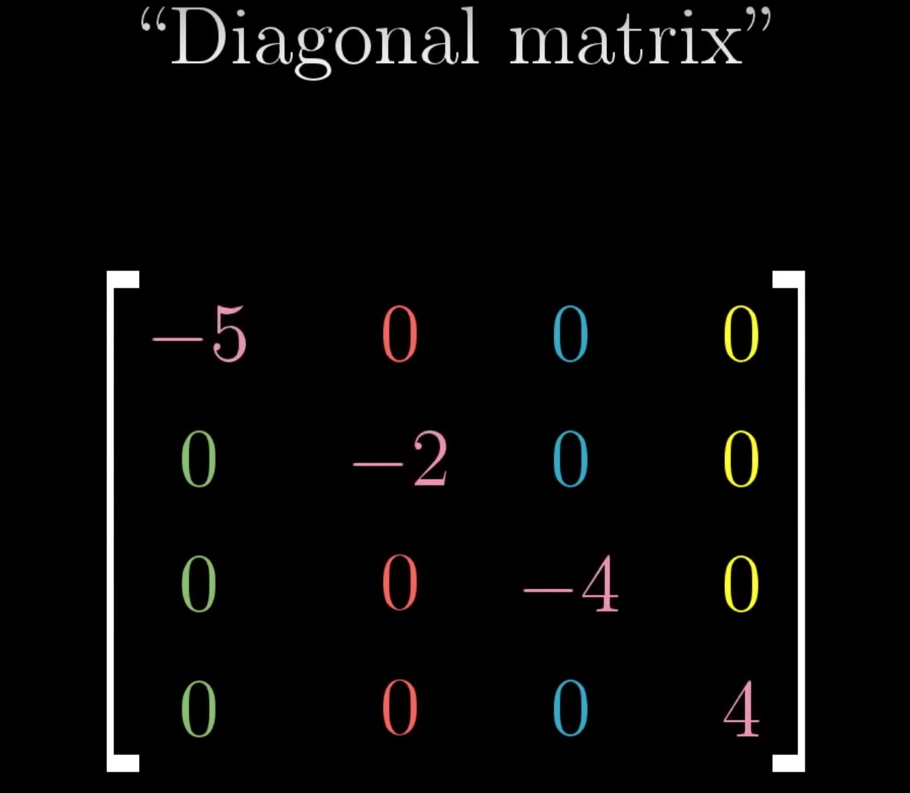

Finally, there is this concept of “eigenbasis”. Basically, it’s about converting your matrix so that your basis vectors are eigenvectors as well. This, supposedly, makes some matrix operations much easier to carry out. However, not all matrices seem to have those eigenvectors and I have no clue how you happen to know that …

All in all, lots of process, lots to digest, but I’m finally a step closer to understanding what I wanted to understand initially – PCA and SVD.

## 11.11.2019

11:00

Going to watch the last episode of 3Blue1Brown series. Then going to jump into PCA to try to understand again.

I remember that it had something to do with covariances matrix, so I need to figure that out as well.

So important thing to note is:

1. Vector can be anything. And funny enough, even functions ARE vectors, just infinitely many of them
2. In order for function to be linear, it has to satisfy two properties:
   1. output of vector addition has to be same as output of applying function to vectors separately and then adding the result.
   2. Applying transformation to scaled version of vector, has to be same as first applying the function then scaling the result
3. Derivative function is an example of LINEAR transformation

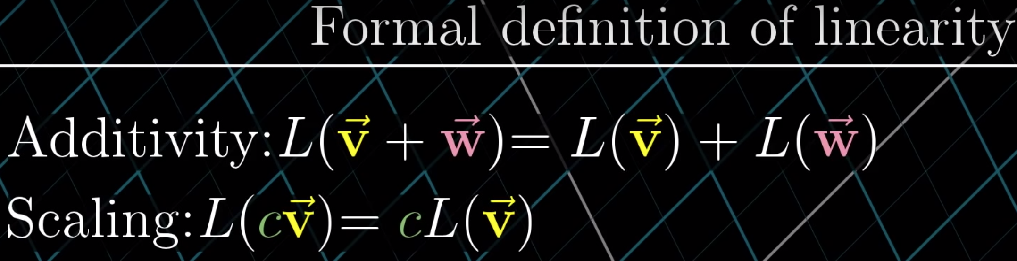

Funny enough, stuff from linear algebra can be applied to functions:

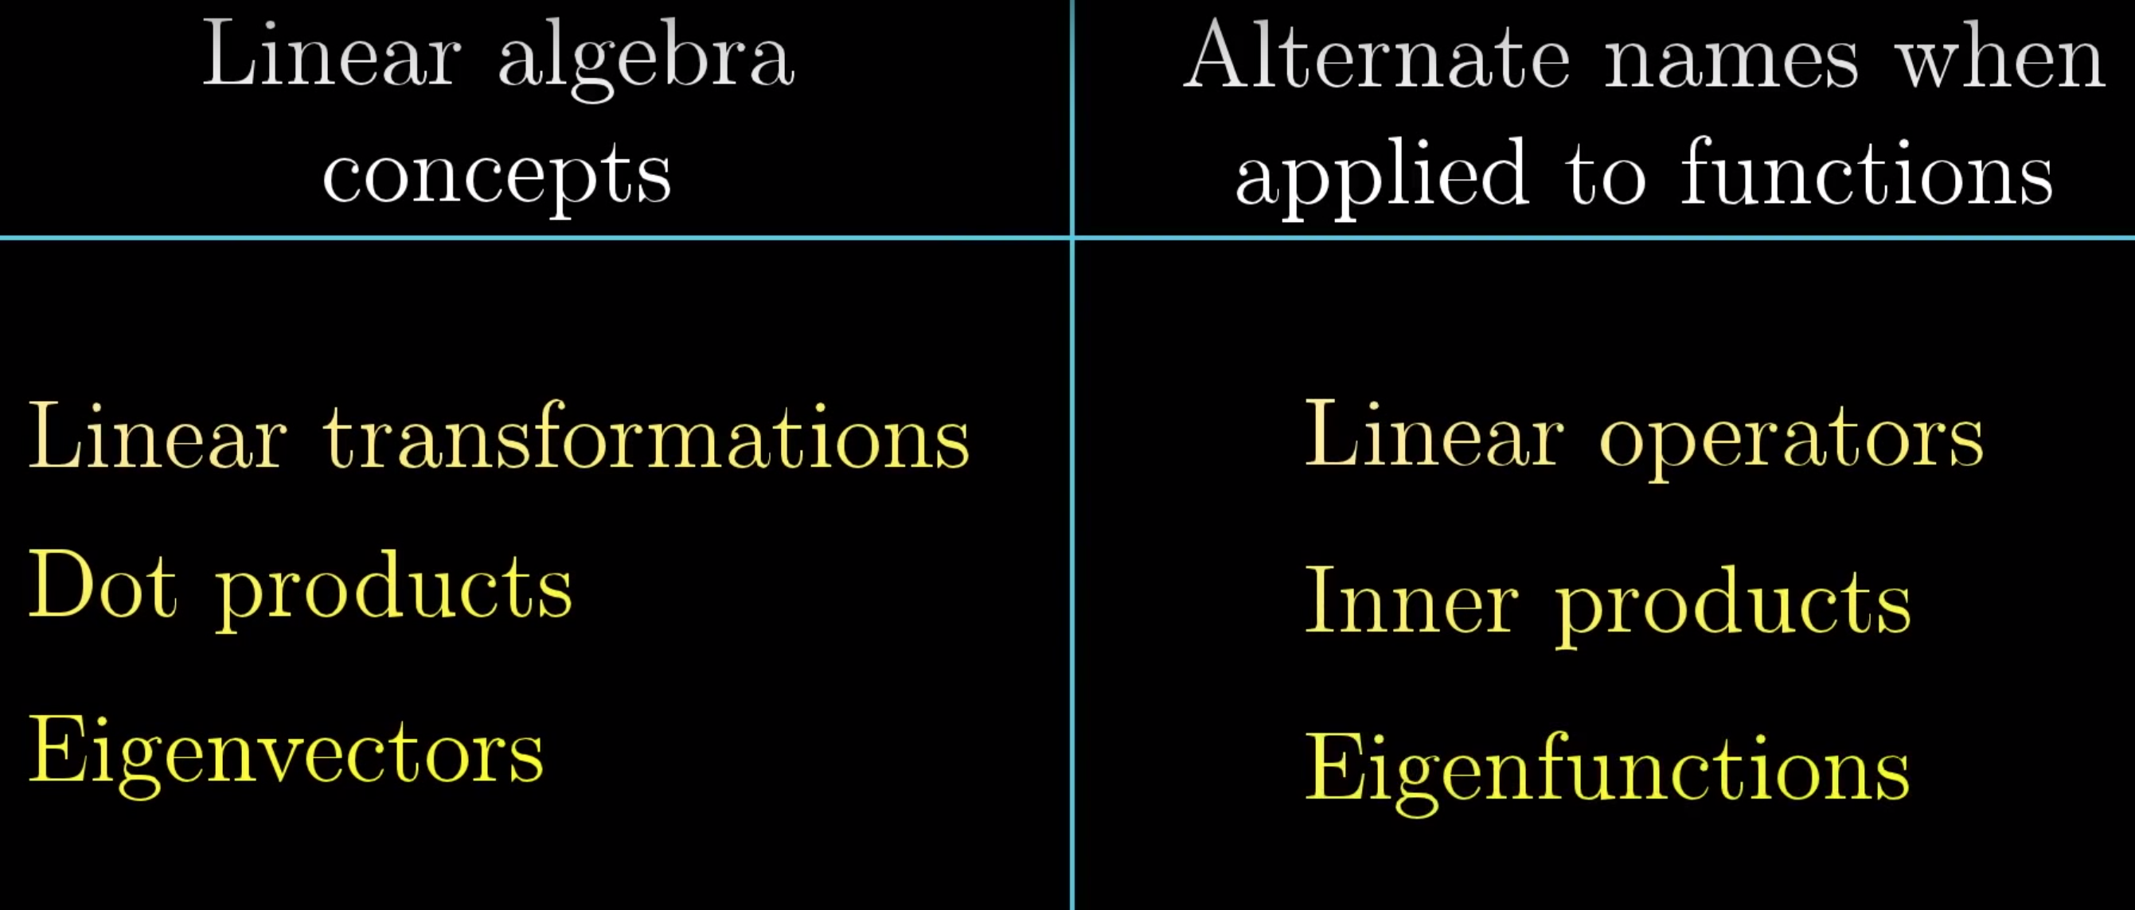

So, the point of this last lesson was that, vectors are just an abstract notion. They can be arrows, sequences of numbers or functions … In order for “something” to be treated as “vector space”, it has to confront to 8 axioms:

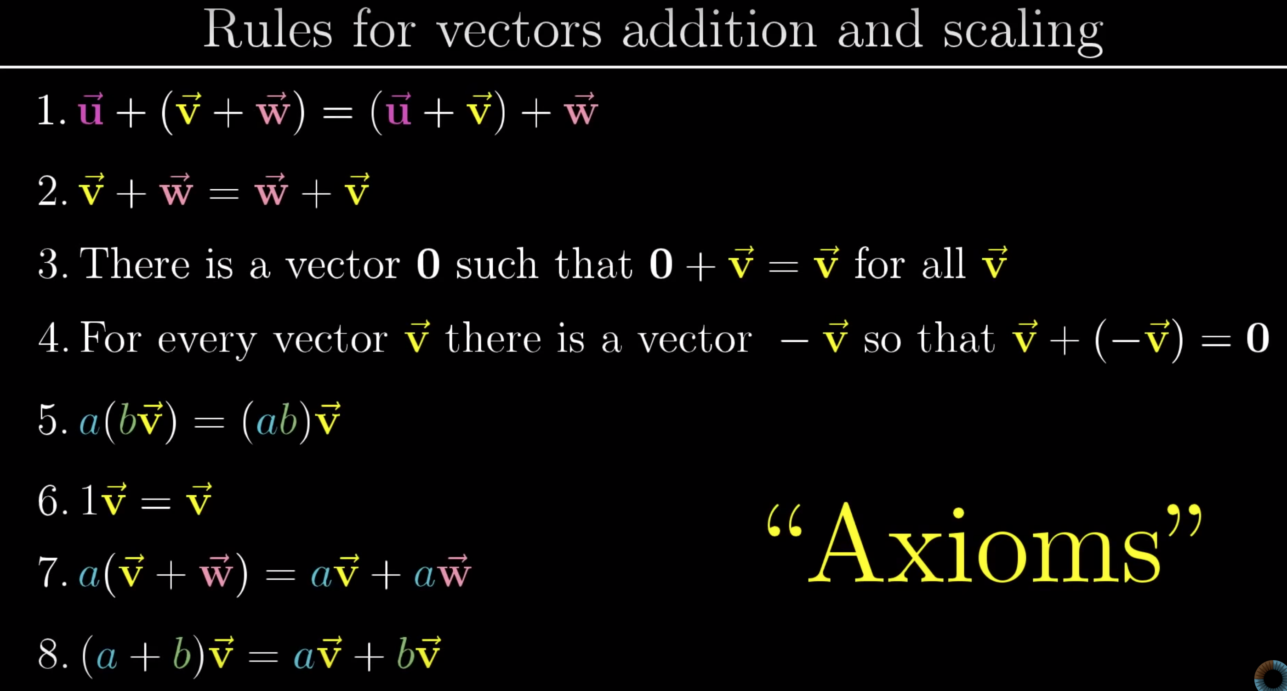

Just … purely … awesome ☺

Ok, next step is, let’s see a bit about PCA and it’s inner workings.

So, quick reminder, this is what I said 5 days ago:

*So, next tasks 🡪 recall the Dot product, try to understand the PCA and hopefully try to understand the SVD. Yeah, it can be done using the numpy library but I actually want to see what it is really …*

Well, I recalled what Dot product is, and now it’s time to try to put that into understanding what PCA is. Also, what I want to do is find some language/program/environment where I can play with vectors .. Maybe just learning the 3Blue1Brown’s Math lib is all I need?

Ok so, after watching the [first video](https://www.youtube.com/watch?v=kw9R0nD69OU), the point is that what PCA does is finds the basis where if we project all vectors we get a maximum variance. So that’s kind of the essence of it, the next axis has to be orthogonal to the first one (cosine = 0?). And that’s actually, probably, the ESSENCE of it. Now, from what I understood, how it FINDS that is something called the Eigenproblem? Or Eigenresolver? Not sure yet but I’m checking.

Ok, at this point I actually tend to believe I do get some wider picture. This is the first time that I was able to read the “Recommender systems” book and to, more or less, follow what’s being talked about in “Latent factor models”. Which is a NEW thing for me, even being able to follow …. Hu-fuckin’-ray, I say!

So, my overall picture is that, apparently, by matrix decomposition, you actually decompose the data into those hidden factors which seem to describe the movies and users preferences. As in 🡪 you actually decompose the user x movie matrix into users and their preferences for certain genres, while other matrices represent the movies and their genres. I would assume that somehow, through combination of these, you get the predicted rating or whatever … Yet, still a road ahead of me.

Ok, here’s a battle plan for next hour or so:

1. Read about knowledge-based systems and eventually “other” types of systems
2. Try playing with Manim library. I’d like to get a sense of what I’m actually doing at all and eventually try to figure out SVD stuff
3. Write about knowledge-based systems

**It’s important noting that, at this point, I’m still pretty blurry about what SVD does.** As in – it looks like I’ll actually never understand it in order to implement it fully.

## 13.11.2019

08:00

Battle plan for today:

1. Try implementing SVD against data from the book
2. Read once more about the Matrix Factorization in Book

Also, it’s worth mentioning how yesterday I actually, all of a sudden, started feeling comfortable talking about SVD and PCE. Like – yeah, that all makes sense! And it did. It all started coming together and now I’m like – funny that I didn’t understand it the first time … :-D

Hm, ok I’m kind of starting to get a taste for it …

Useful resources that I read today:

<https://github.com/khanhnamle1994/movielens/blob/master/SVD_Model.ipynb>

<http://nicolas-hug.com/blog/matrix_facto_4> (this page recommends some nice resources)

<http://theory.stanford.edu/~tim/s15/l/l9.pdf>

Ok interesting thing I read in <http://theory.stanford.edu/~tim/s15/l/l9.pdf> is that you can choose any default value to replace missing ones. This includes – zero, row mean or column mean. Generally, it can be experimented with …

I’d like to read a bit more about this on <http://theory.stanford.edu/~tim/s15/l/l7.pdf>. These are some lecture courses from Stanford [CS168 (modern algorithmic toolbox)](https://web.stanford.edu/class/cs168/index.html). However, I have to make sure not to dive too deep into all of this …

Also could be interesting to look into: <https://cs.stanford.edu/>

## 14.11.2019

08:00

Ok, today I’m determined to do two implementations:

1. Implement what I started yesterday – SVD using sample data from book
2. Implement for MovieLens

In the afternoon I’m hoping to do some writing about Matrix factorization, but if that fails, I’ll leave it for tomorrow morning.

Funny enough, the predictions that I’m getting are pure shit … Not sure why :^) I’ll see what will SurpriseLib give me ..

Well, looks like the shitty results I’m getting is because the data is rather stupid … Which would make sense, in a way …

Well, Surprise lib seems to be giving me crap as well … Which is rather strange.

Ok it very well could be that my dataset from book is shit actually … I’ll try against MovieLens tonight and especially top-k recommendations using <https://surprise.readthedocs.io/en/stable/FAQ.html#how-to-get-the-top-n-recommendations-for-each-user>

18:20

Worked out, I’m pretty exhausted but I want to do some writing about Matrix Factorization methods.

Did 30mins of writing then Pawke came. Will finish tomorrow.

## 15.11.2019

08:00

Going to finish the writing about Matrix Factorization. Maybe implement it as well but I don’t think it’ll happen.

08:33

Ok, I’m done writing about the Matrix Factorization. Time to try doing some code now.

What I noticed is that rating is not a simple estimation of what was factorized back. Rather, it seems that it should have been calculated based on … some stuff. I yet have to check what that is.

Well, funny enough, I managed to read and understand most of Matrix Factorization chapter for now (Chapter 3.6). That wasn’t really expected but funny enough – it happened.

Well, one thing is for sure – I have to learn calculus and differentiation. It shows up too often to be ignored or skipped …

18:30

After a workout, I’m completely exhausted for the day but I want to do a bit of coding for SVD. Let’s see what I can come up with within an hour …

Ah yeah, I’ll try against the book data first ;-)

Interestingly enough, the approach which can be applied is:

1. Mean center rows
2. Do factorization
3. Turn back to original matrix
4. Replace missing values with “predicted” ones
5. Go back to #2 and repeat. This seems to give better results and usually 4-5 iterations are more than enough. Interesting

And all of a sudden, I made everything work like a charm!! Now that’s a fucking smell of victory!!! It works!!!!!

To answer my question from 9 days ago 🡪 yeah, everything that I invested time in was worth every single moment of it!!!!

So I managed to implement SVD like it was a piece of cake! And I implemented the recommender system. Can’t even explain how happy I am :-D

What I’ll leave for tomorrow is to write dowh the results and eventually play with PCA a bit in order to try the optimal number of components.

So long!

## 18.11.2019

08:00

After an amazingly relaxing weekend, continuing to work on this.

So the battle plan is as follows:

1. Write down the results and writings for Matrix Factorization
2. Write a conclusion of the thesis
3. Grayscale all images
4. Proof-reading and contact professor

I’m aiming at doing #1 and starting #2 today.

08:30

Ok, I’m done with #1. Time to start working on the conclusion of thesis. It kind of makes me anxious as I’m feeling like I’ll have no idea what to write here, etc. No idea why, I’m just anxious about doing this and I feel like even avoiding doing it …

But, to hell, with it, let’s give it a shot …

09:00

Well, that went better than planned ☺ I managed to write a Conclusion which I think I’m satisfied with.

Next step (tonight will be to fill in the Appendix) and to update the images to grayscale them.

After that, I’ll do a proof-reading and contact the professor tomorrow (hopefully).

18:30

Ok, after a great workout and really a productive day, time to finish this thesis.

This is what I’m going to do:

1. Move the Jupyter notebooks to the same folder
2. Grayscale all images
3. Write the appendix
4. If time permits – proof reading